ADVANCED PHYSICAL THERAPY & HEALTH SERVICES
MEDICAL HISTORY INTAKE FORM
Name: _________________________________ Age: ________ Today’s Date: ____________

Full Address: ________________________________________________________________________
Birth Date: ___/___/______ Height (inches): ____________ Weight (lbs): _________ BMI: _________
Cell Phone: ___________________ Home Phone: ___________________ Email: __________________
REASON FOR TODAY’S VISIT
[ ] New Complaint [ ] Reoccurring Complaint [ ] Chronic Complaint
Please rate the level of your pain / disability:
BEST - 0 1 2 3 4 5 6 7 8 9 10 - WORST
Date of injury/start of pain: ____________________
How did pain occur? ___________________________________________________________
Did this occur at work? Yes No
BODY DIAGRAM
Please indicate below the location and type of symptoms you are experiencing:
S – Sharp Pain A – Aching, Dull Pain
N – Numbness T – Tingling
B- Burning O – Other: ______________

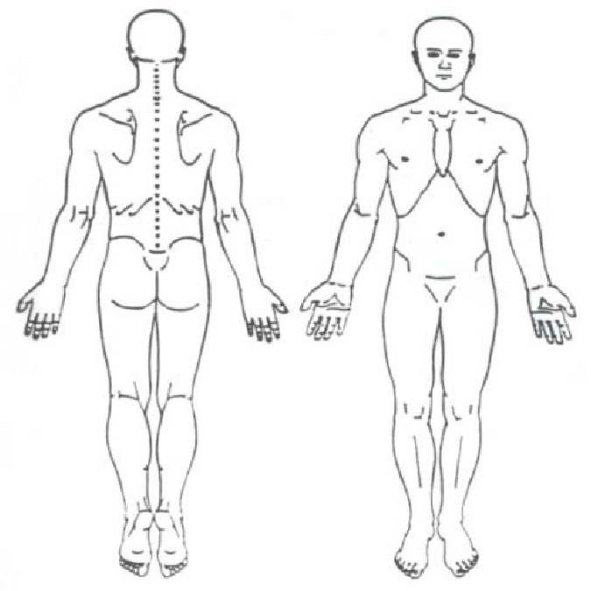

Are you currently working? Yes No
Right
Left
Left
Previous Medical History- Please check all that apply:

__ Heart Condition __ High Blood Pressure
__ Cancer/Tumor __ High Cholesterol
__ HIV/AIDS __ Epilepsy/Seizure
__ Diabetes __ Allergies
__ Metal/Plastic Implants __ Asthma
__ Stroke __ Rheumatoid Arthritis
__ Impaired sensation __ Pacemaker
__ Impaired hearing/vision
__ Osteoporosis/osteopenia

History of smoking? Yes No
If yes, how often? ________________________________

FEMALES: Are you or could you be pregnant? Yes No

Current Medications: _____________________________
__________________________________________________________________________________________________________________________________________

Please list any surgeries:
________________________________________________________________________________________________________________________________________________________________________________________
__________________________________________
WORK INFORMATION:
Employer: _________________________________________ Work Phone: _______________
Occupation/Title: ______________________________________________________________

PRIMARY PHYSICIAN:
Name: _______________________________________ Phone: ________________________
REFERRING PHYSICIAN (if different from above):
Name: _______________________________________ Phone: ________________________

INSURANCE INFORMATION:
Who is financially responsible for this bill (name & relation)?
__ Self-Pay (Cash/Credit/Check)
__ Patient’s Medical Insurance
__ Workman’s Compensation Insurance
__ Other: __________________________________________________

Are you currently receiving Home Health Services? ___ Yes ___ No

If applicable, who is your current Home Health Agency? ______________________________
If you are in a current episode of any home health service, your insurance will not cover outpatient physical therapy. You will be responsible for your bill.
Please initial ___________

EMERGENCY CONTACT INFO:
Name: _______________________________ Phone Number: _________________________ Relationship to Patient: __________________

Thank you for choosing Advanced Physical Therapy to be your provider!
Please let us know who referred you to us:

__ Physician: _________________________________
__ Friend: _____________________________________
__ Former/current Patient: ________________________
__ Internet Search
__ Advertisement
__ Social Media
__ Other: ______________________________________
Federal Compliance of Confidentiality

Please read the following statements and answer accordingly:
- I agree, that by allowing the staff of Advanced Physical Therapy and Health Services to copy my insurance cards, that I willingly assign benefits to be paid directly to the therapist treating me.

Yes______ No______
- I agree, as a patient of Advanced Physical Therapy and Health Services, any co-pays, deductibles, and benefits that are deemed “not covered” by my insurance company are my responsibility and agree to pay my part of any charge left unpaid. This includes denials by Worker’s Compensation carriers, record copy fees, etc.

Yes______ No______
- I give the staff/therapists of Advanced Physical Therapy and Health Services the authorization to call my cell, home, or work number provided on my demographic sheet to notify me of upcoming appointments, test results, or billing issues.

Yes______ No______
- I authorize Advanced Physical Therapy and Health Services to submit all my claims on behalf of the therapists and doctors. I agree that Advanced Physical Therapy and Health Services may contact me at my home or work numbers provided regarding any billing issues or questions that they may have on behalf of the doctors.

Yes______ No______
- I authorize the release of any notes/medical records pertaining to my medical condition that will assist in the continued treatment of my care to Advanced Physical Therapy and Health Services. This includes referring physicians/primary care physicians, specialists, physical/occupational therapy department/provider or any other center that I have had medical treatment with or will have as a result of my treatment, as requested by the patient.

Yes______ No______

_________________________________ ____________________
(Patient/Guardian Signature) (Date)

ADVANCED PHYSICAL THERAPY & HEALTH SERVICES
ATTENDANCE, BILLING, & TREATMENT AREA POLICIES

ATTENDENCE
- Late Appointments: $30 Fee (if more than 10 minutes late to scheduled time)
- It is important that the patients keep their scheduled appointments and show up on time. Treatment sessions will be canceled if the patient is more than 15 minutes late for their scheduled appointment. If you are more than 10 minutes late for your appointment, you will be charged a $30 late fee. If you are going to be late, please call us to see if other arrangements can be made.
- Missed Appointments or Same-Day Cancellations: $100 Fee
- If you need to cancel an appointment, please call 24 hours in advance. Our policy is to charge $100.00 for missed appointments or if they are not cancelled within 24 hours. Please help us serve you and others better by keeping scheduled appointments.
- If the patient misses or cancels three appointments in a row, the physical therapist may cancel future existing appointments. The patient may call to reschedule these appointments at another time.

BILLING
- The patient and/or responsible party agrees to pay balance due within 30 days of the date of the first invoice. After 60 days, the balance will incur a $10.00 late fee per month that the balance remains outstanding. If a balance remains unpaid for more than 90 days, the medical provider may refer the account to a third-party agency or attorney for collection and legal action. The patient shall be responsible for all collection costs and reasonable attorney’s fees incurred in the collection of the account.

TREATMENT AREA POLICIES
- For the safety of our patients, children are only allowed in the treatment area if they are the patient or if accompanied by an adult.
- Out of respect for other patients, please do not wear any perfumes/colognes to the physical therapy sessions.
- Patient confidentiality is a priority. Do not ask the therapists/staff about other patients in the clinic. We protect our patients’ privacy, as well as yours.

Signature: ____________________________________________________________
Date: ________________________

